**Practical File**

1. Analyse the existing IRCTC website and improve the website using HTML

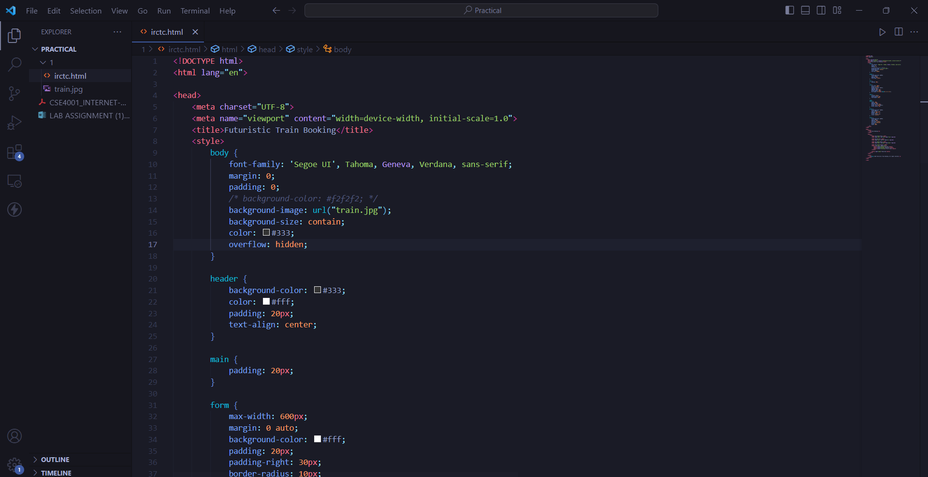 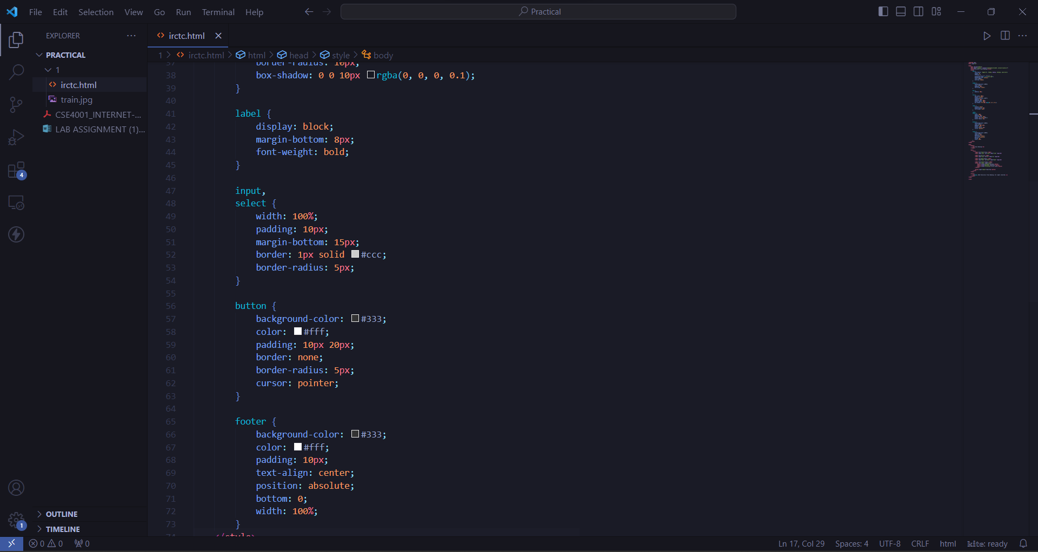 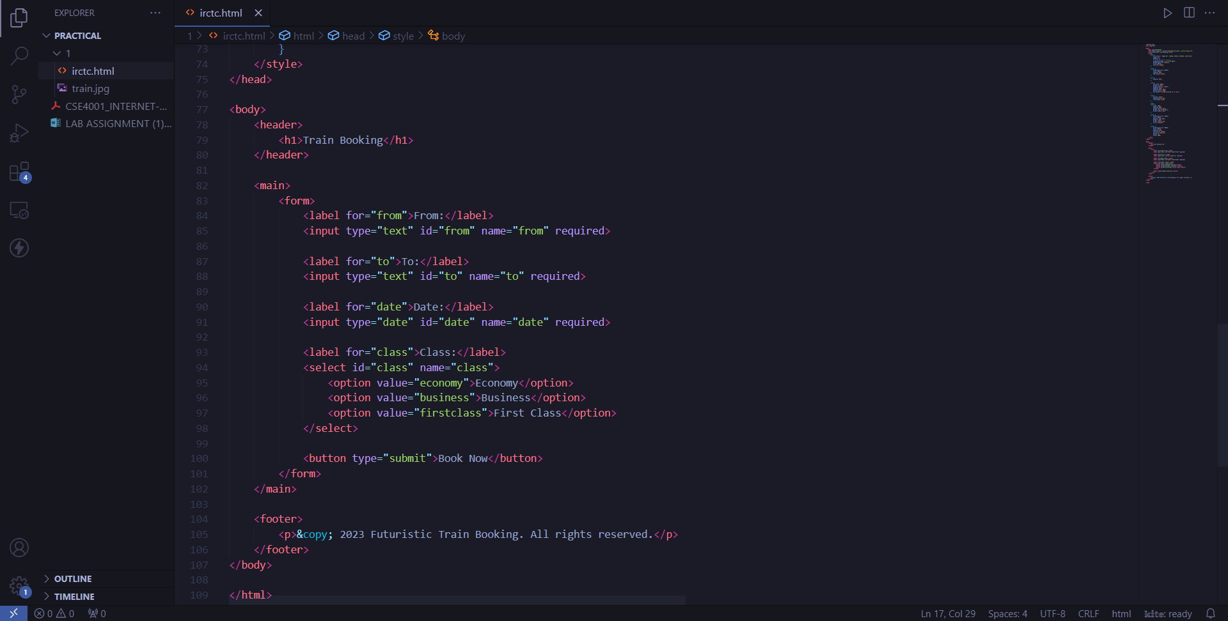

Train booking page:

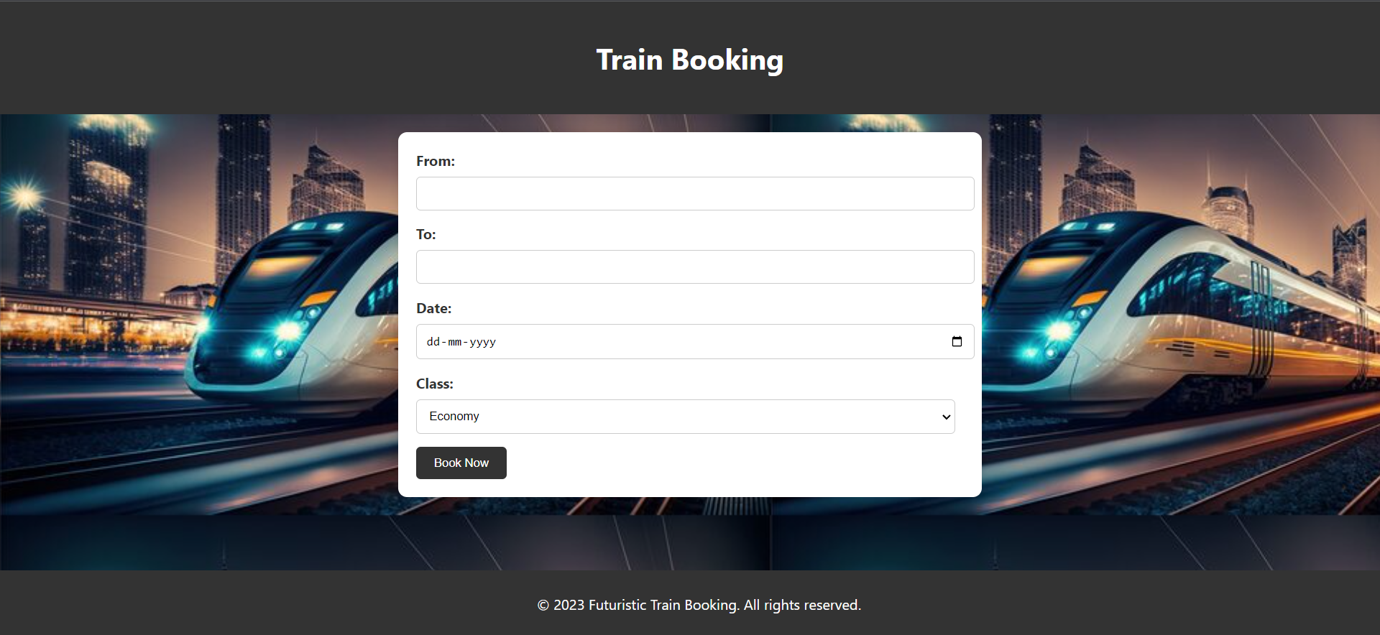

1. Design an English alphabet chart such that on clicking the alphabet the appropriate example must be displayed using HTML client-side image mapping

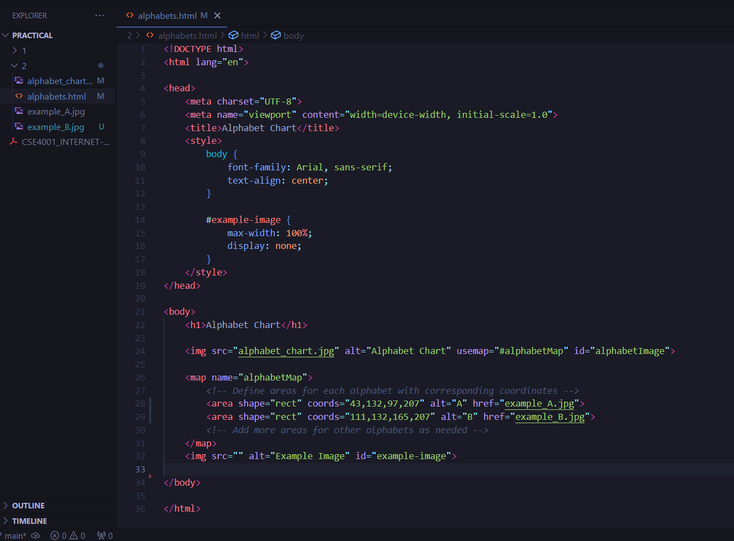

Website:

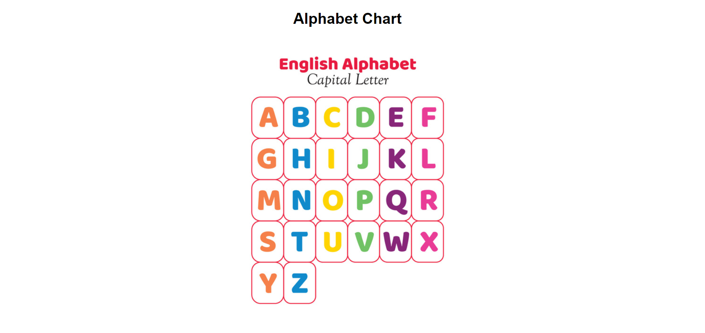 

1. Design the online periodic table using CSS